**TASK:1**

#### **Create a uniform subdivision of the interval -1.3 to 2.5 with 64 subdivisions.**

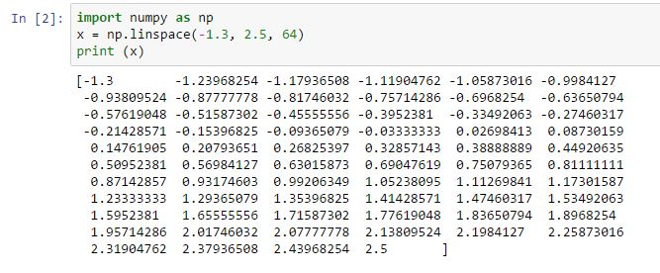

1. **Generate an array of length 3n filled with the cyclic pattern 1, 2, 3.**

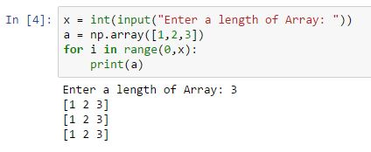

#### **Create an array of the first 10 odd integers.**

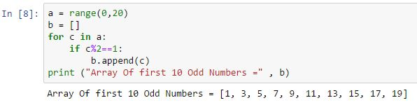

#### **Create a 10 x 10 arrays of zeros and then "frame" it with a border of ones.**

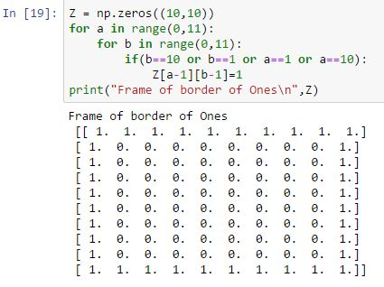

#### **Create an 8 x 8 array with a checkerboard pattern of zeros and ones using a slicing + striding approach.**

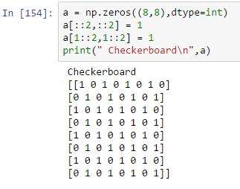

**TASK: 2**

#### **1. Generate a 1D NumPy array containing numbers from -2 to 2 in increments of 0.2. Use optional start and step arguments of np.arange() function.**

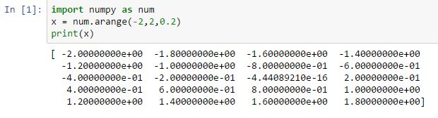

#### **2. Generate another 1D NumPy array containing 11 equally spaced values between 0.5 and 1.5. Extract every second element of the array.**

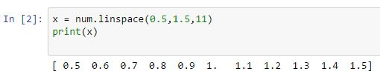

**3. Create a 4x4 array with arbitrary values. Extract every element from the second row.**

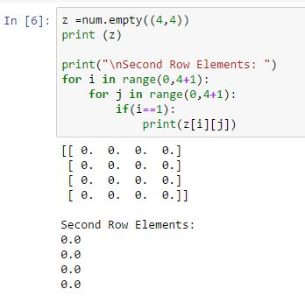

#### **4. Extract every element from the third column.**

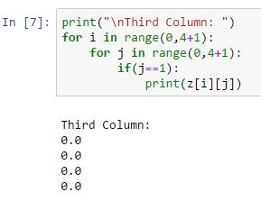

#### **Assign a value of 0.21 to upper left 2x2 subarray.**

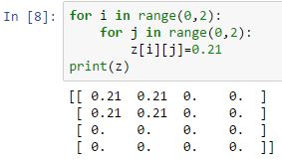

**TASK:3**

#### **Derivatives can be calculated numerically with the finite difference method as:**

**f'(x)=f(x+del(x)) - f(x-del(x))/2*del(x)**

**Construct 1D Numpy array containing the values of x in the interval [0,π/2] with spacing Δx=0.1. Evaluate numerically the derivative of sin in this interval (excluding the end points) using the above formula. Try to avoid for loops. Compare the result to function cos in the same interval.**

